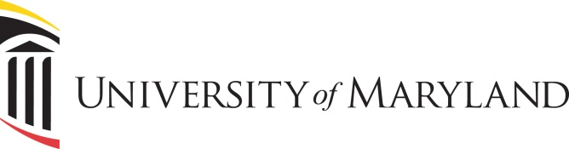

University of Maryland Center of Excellence in Regulatory Science and Innovation (M-CERSI)

Request for Proposals for Collaborative Workshops from University of Maryland or FDA scientists
Proposals due January 22, 2021

This announcement is a Request for Proposals for future M-CERSI Collaborative Workshops. The mission of M-CERSI is to foster the development of regulatory science – the science of developing new tools, standards and approaches to assess the safety, efficacy, quality and performance of FDA-regulated products. M-CERSI intends to fund up to five (5) M-CERSI Collaborative Workshops (up to $5,000 per workshop; if cost is higher, there is a need to look for sponsorship from non-federal entity, registration fee, or FDA Center/Office funds), based on submissions from FDA and University of Maryland scientists. M-CERSI Collaborative Workshops should address an area of regulatory science identified by FDA and/or University of Maryland scientists (see FDA Center/Office Regulatory Science Research Priority Areas for CERSI Program for topics).

Planners are encouraged to collaborate with FDA scientists, academic scientists, and industrial scientists, if appropriate, concerning the workshop regulatory science topic. The activity can be held either at the University of Maryland; FDA main campus in White Oak, Silver Spring, Maryland; or at other nearby venues. During the COVID-19 pandemic, alternatively, workshops can be conducted virtually with no in-person attendance (i.e., using a webinar conferencing platform for all attendees). Past conferences in which M-CERSI has collaborated with FDA have focused on: pediatric drug development approaches; biomarkers; bioequivalence issues and methods; patient preferences, predictive immunogenicity, validation and qualification of new in vitro tools and models for pre-clinical drug discovery; big data approaches and applications; nanotechnology product assessment; mass spectrometry methods; biologics characterization; countermeasures development approaches; standards development in tissue engineering.

Criteria for Proposals for Collaborative Workshops from FDA and University of Maryland scientists

Eligibility.
Eligible to submit proposals:
- FDA staff
- Full-time faculty having primary academic appointments within the Baltimore or College Park campus of the University of Maryland.

Development of a workshop proposal in collaboration with FDA staff and/or full-time faculty having primary academic appointments at the University of Maryland is strongly encouraged. James Polli (jpolli@rx.umaryland.edu), William Bentley (bentley@umd.edu), and Donna Blum-Kemelor (Donna.Blumkemelor@fda.hhs.gov) can be contacted regarding questions about preliminary ideas.

Workshop Benefits. Proposals should include details on how the workshop will benefit FDA and the M-CERSI program and could include information on how FDA scientists, academic scientists and, if appropriate, industrial scientists will collaborate on workshop planning in addressing current regulatory science workshop topics. Proposals will be scored by M-CERSI reviewers based upon the feasibility of the proposed workshop, regulatory impact upon FDA mission, and the degree to which the topic addresses a current area of regulatory science identified by FDA scientists.

Expectations. Collaborative workshops with FDA are educational and do not involve discussions concerning FDA policy, development of consensus recommendations, or solicitation of comments from the public about FDA policy. FDA holds public meetings (21 CFR 10.65(b)) and Part 15 hearings (21 CFR 15) to discuss FDA policy. All FDA-CERSI Collaborative Workshops will be open to the public.

FDA-CERSI collaborative workshops conducted under this cooperative agreement are not permitted to provide consensus recommendations from the workshop to FDA in accordance with the Federal Advisory Committee Act (FACA) or otherwise provide consensus recommendations to others (e.g., the public) in accordance with Good Guidance Practice (GGP) regulations at 21 CFR 10.115, in particular 21 CFR 10.115(e).

For a collaborative workshop, it is acceptable to provide online or publish a summary of the views presented by individual speakers and attendees (e.g., proceedings of the workshop; doesn’t have to be verbatim – can be a readable version of a transcript).

Please note that ORSI currently does not have the personnel bandwidth to support organization and co-ordination of workshops. If a workshop moves forward, ORSI requests that the FDA Center/Office collaborating with M-CERSI provide logistical support for the event. For approved M-CERSI workshops, ORSI recommends reviewing the “FDA Center/Office Managed CERSI Collaborative Workshop Responsibilities tables (for workshops at FDA White Oak and those off-site) - for approved workshops, please contact ORSI-CERSI-Team@fda.hhs.gov for those tables. Also, FDA-CERSI Collaborative Workshops websites must include a statement that acknowledges federal support. Contact the email “ORSI-CERSI-Team@fda.hhs.gov” for additional information.

Proposal and review. Proposals should be submitted by January 22, 2021 to ORSI-CERSI-Team@fda.hhs.gov with the subject line “FY21 FDA-UMaryland CERSI Collaborative Workshops Proposals,” with cc: to Donna Blum-Kemelor, ORSI/OCS/OC/FDA at: Donna.Blumkemelor@fda.hhs.gov.

Proposals should be pre-reviewed and approved within respective FDA Centers/Offices and M-CERSI before submission. For collaborative workshops associated with CDER, proposals should be sent to the CDER Research Governance Council (RGC) (email: CDER-RGC@fda.hhs.gov) and receive approval by the relevant CDER RGC representative before submitting applications by 1/22/2021. Proposals must state that the proposed activity will be open to the public and include workshop funding sources. Proposals should include a brief description of the roles and expected responsibilities of FDA and University of Maryland staff organizers. M-CERSI staff provides non-scientific logistical support (e.g., speaker invitations, slide coordination and travel, web registration, CERSI workshop website, facilities for workshops if desired, and day of workshop assistance). Proposals will be evaluated internally by M-CERSI and may be reviewed by the FDA CERSI Steering Committee (i.e., if there are more than five (5) proposals submitted). Applicants should not expect critiques of their proposals.

M-CERSI Proposals will be reviewed for how well the project will foster the development of regulatory science, including having regulatory impact. If key FDA and/or University of Maryland staff who may co-organize or participate in the proposed event are known, please provide their names in the proposal. If the proposal is developed by Univ. Maryland faculty, then the M-CERSI committee may also assist in identifying appropriate FDA staff members.

Allowable expenses. Allowable expenses for workshops include virtual online platform support (e.g., Web-Ex or Zoom) if needed, speaker travel expenses, printing of agendas, and posters. Note: if an FDA Center/Office provides funds to UM CERSI to support a workshop, both direct and indirect costs need to be included in the budget.

Expenses not allowed. Salaries for PIs and any co-PIs, secretarial support; food (unless travel-related); general telephone services and postage; purchase or rental of equipment for new research; alterations or renovations of laboratory space; purchase of laboratory or office furniture; purchase or binding of periodicals and books; unrelated travel; dues and memberships in scientific societies. Charging of indirect costs after FDA funds have been awarded to the UM CERSI is not allowed.

Conditions of the award. Awards will be made to the University of Maryland academic principal investigator or key contact and are not transferable without prior approval by Drs. Bentley and Polli. Funds should be budgeted for completion over the award period.

About M-CERSI
M-CERSI is an FDA-sponsored center at the College Park and Baltimore campuses of the University of Maryland ( www.cersi.umd.edu ). The mission of the Center is to foster the development of regulatory science – the science of developing new tools, standards and approaches to assess the safety, efficacy, quality and performance of FDA-regulated products.

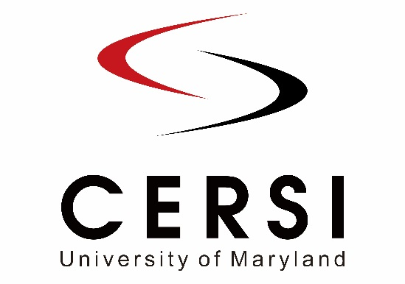

Proposal for
University of Maryland Center of Excellence in Regulatory Science and Innovation (M-CERSI)
Collaborative Workshop (1/22/2021)
- FDA staff member name(s):

- Affiliation(s):
- Email(s) and phone number(s):

2. University of Maryland collaborator name(s):

  - Affiliation(s):
  - Email(s) and phone number(s):

- a. For FDA/CDER related collaborative workshops, note who in the CDER Research Governance Council (RGC) approved this application and on what date:
b. For other FDA Centers/Offices, note who approved this application and on what date:

- Title of proposed collaborative workshop:

- Anticipated possible date of event (approximate):

- Anticipated possible location of event (e.g., FDA White Oak campus Great Room, UM-Baltimore campus, or other venue, or webinar-only workshop):

- If this workshop will be conducted at a physical location other than FDA’s White Oak campus Great Room, is there a plan for the workshop to be (these options are highly encouraged):
  - Web-cast allowing for virtual attendee participation? _________________________________________
  - Video-recorded allowing for the public to view workshop sessions later on? _______________

- Total budget (in dollars) and budget justification

- Workshop funding source(s): (e.g., M-CERSI core funds, FDA Center/Office (indicate which), registration fees, other sources)

Submit proposals (this cover page; two-page maximum description of proposed collaborative workshop, with at least one literature reference; biosketches of organizer[s]) by January 22, 2021 to ORSI-CERSI-Team@fda.hhs.gov with the subject line “FY21 FDA-UMaryland CERSI Collaborative Workshops Proposals,” with cc: to Donna Blum-Kemelor, ORSI/OCS/OC/FDA at: Donna.Blumkemelor@fda.hhs.gov.

